A |  |  |  |  |  |  |  | Fröhe  Weihnachten  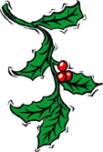  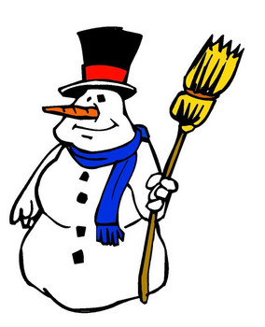
  W | E | I | H | N | A | C | H | T | E | N | C | T | E | R
  B | I | J | K | L | M | N | V | C | X | H | W | N | Y | G | F
  C | N | E | R | T | Y | K | E | R | Z | E | E | R | U | G | H
  D | T | C | V | B | N | N | M | J | A | I | R | E | I | L | J
  D | E | Z | E | M | B | E | R | K | S | L | T | T | O | U | S
  E | R | W | E | R | T | Y | U | L | D | I | Y | S | P | H | C
  F | H | E | P | P | I | R | K | H | F | G | G | H | O | W | H
  F | R | O | H | E | W | E | I | H | N | A | C | H | T | E | N
  G | D | F | S | C | H | N | E | E | E | B | W | E | T | I | E
  H | M | R | Q | W | E | R | T | Y | U | E | D | F | G | N | E
  L | I | S | D | F | T | A | N | N | E | N | B | A | U | M | F
  K | S | C | E | R | A | S | D | F | G | D | H | J | J | M | L
  M | T | A | D | V | E | N | T | K | R | A | N | T | Z | M | O
  L | E | B | K | U | C | H | E | N | Z | X | C | V | B | N | C
  N | L | J | K | N | N | A | M | E | E | N | H | C | S | J | K
  G | E | S | C | H | E | N | K | E | K | L | Y | Y | E | R | E
Find these words:
Fröhe Weihnachten  Winter  Heiligabend  Krippe  Schneeflocke  Tannenbaum  Geschenke |  |  | Dezember  Glühwein  Mistel  Schneemann  Weihnachten  Stern  Schnee |  |  |  | Kerze  Lebkuchen  Adventkrantz
Match the English words with the German words above:
_________________  _________________  _________________  _________________  _________________  _________________  _________________  _________________  _________________ |  | Merry Christmas  Winter  Christmas Eve  Manger  Snowflake  Christmas tree  Present  December  Mulled wine |  |  | _________________  _________________  _________________  _________________  _________________  _________________  _________________  _________________ |  |  |  | Mistletoe  Snowman  Christmas  Star  Gingerbread  Snow  Advent wreath  Candle

